Summary of ITECH-3101

week 3 _ Lab Exercise

Created by: Boris Wijaya (30393908)

Exercise of Project 1 - Installation process of Tableau Public

On this project, I was required to install a new software system called Tableau Public from the website provided



After clicking the download button, it shows me the screen to input my details as shown

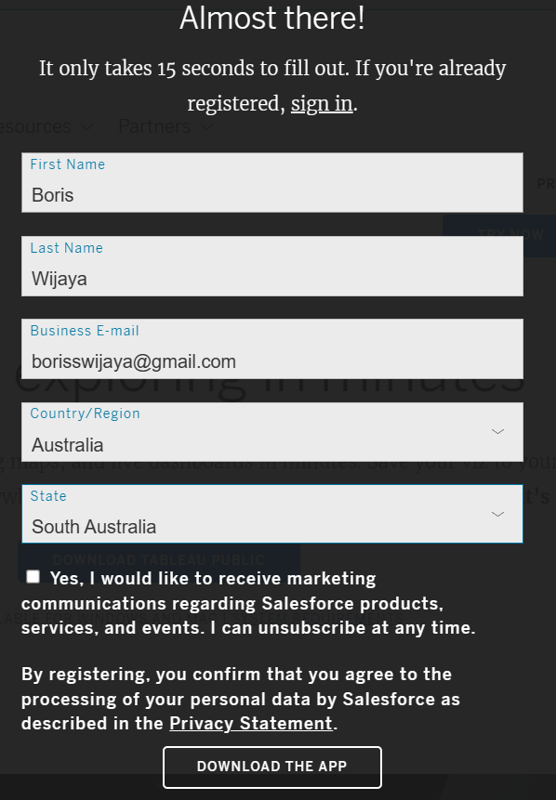

After entering details it will automatically start downloading on my computer

Next, I open the downloaded file and was directed to the screen below

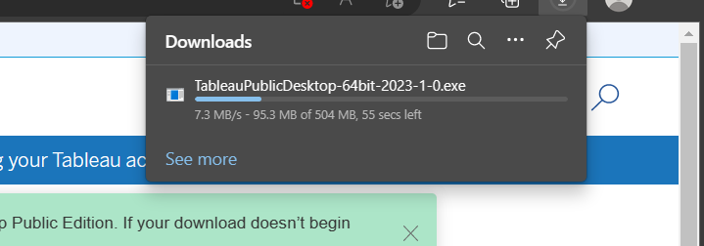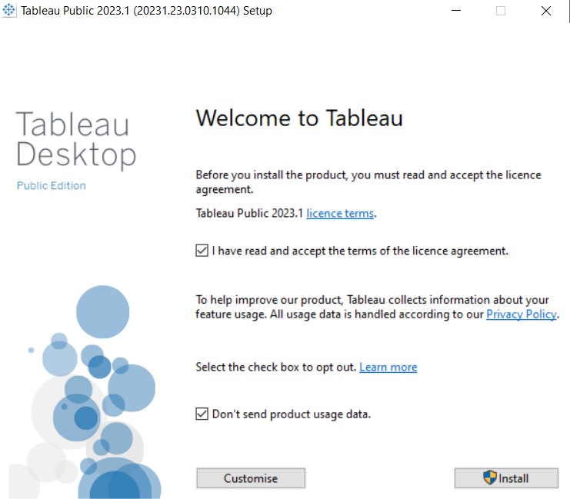

After clicking the install button, I wait for the system to finish installing and then continue to project 2

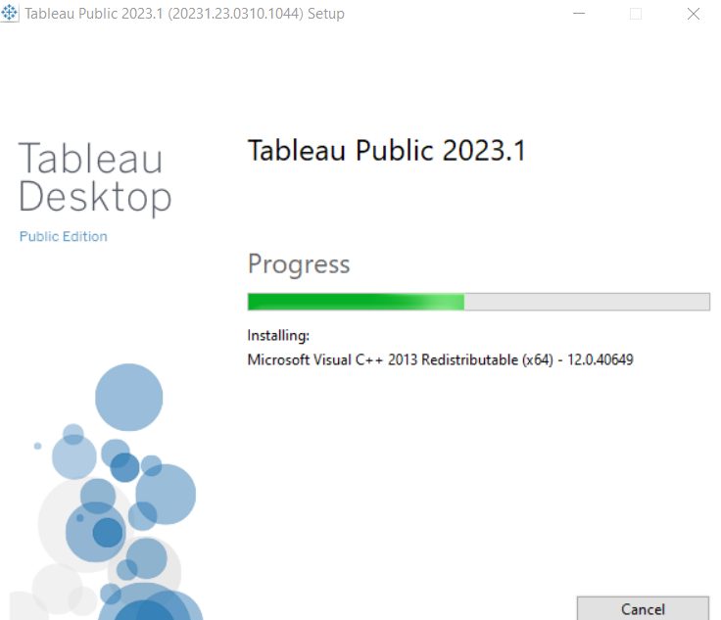

Exercise of Project 2 - Understand the user interface of Tableau

After I finished installing it on project 1, I then click the app, and the screen of the “Start Page” is shown to me

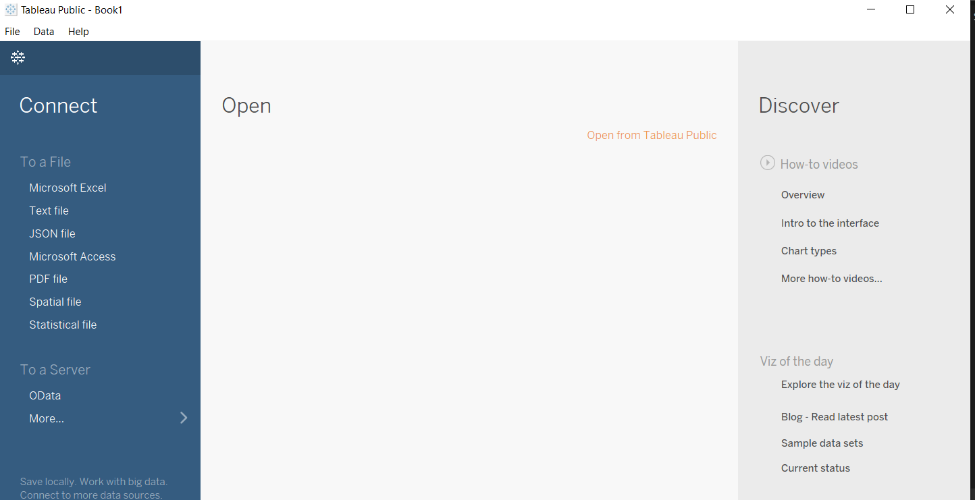

The start page consists of three different panes

1. On the “connect pane”, users can connect data to

The computer by selecting data sources.

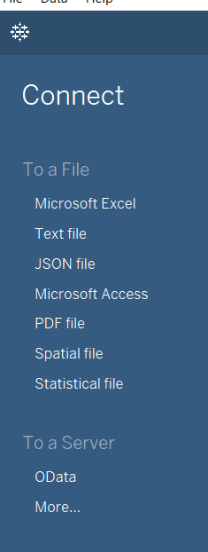

1. On the “open pane”, users can open the work that users recently saved or opened. Users can also use “open pane” to connect some samples provided by Tableau



1. On the discover pane, users can find some training examples, videos, and users forum, etc.

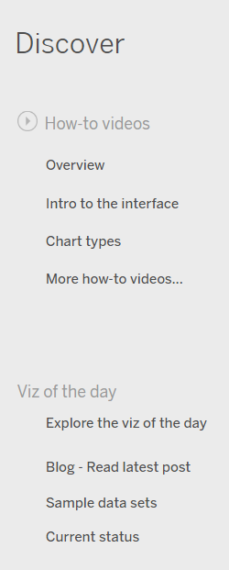

Inside Tableau, there are “sheets” workspaces that are used to build individual projects of data visualization. To open it I click the icon below

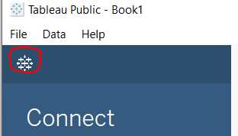

And then it will automatically open the “sheets” workspaces including all the interfaces on it

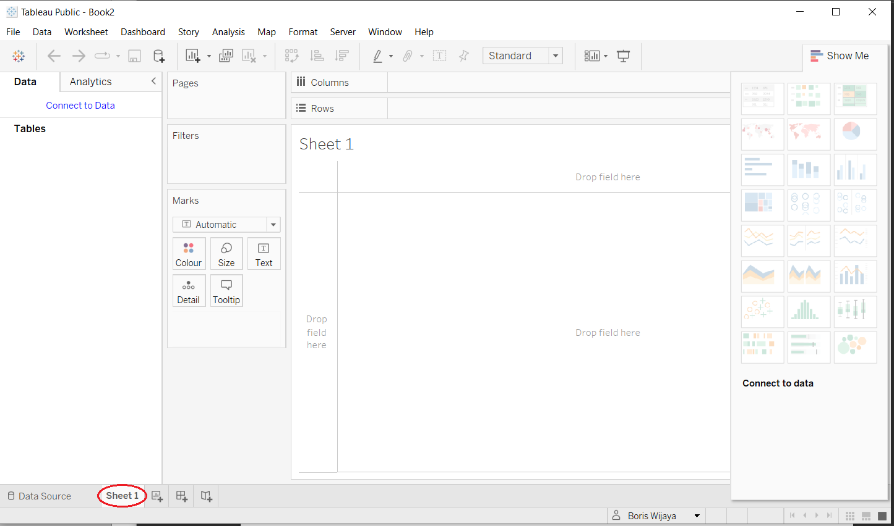

There is also a “dashboard” workspace that can be accessed from the “sheets” page, by simply clicking below icon



It will open the “dashboard” workspaces that are used to include several individual sheets, where each sheet shows different views of the data

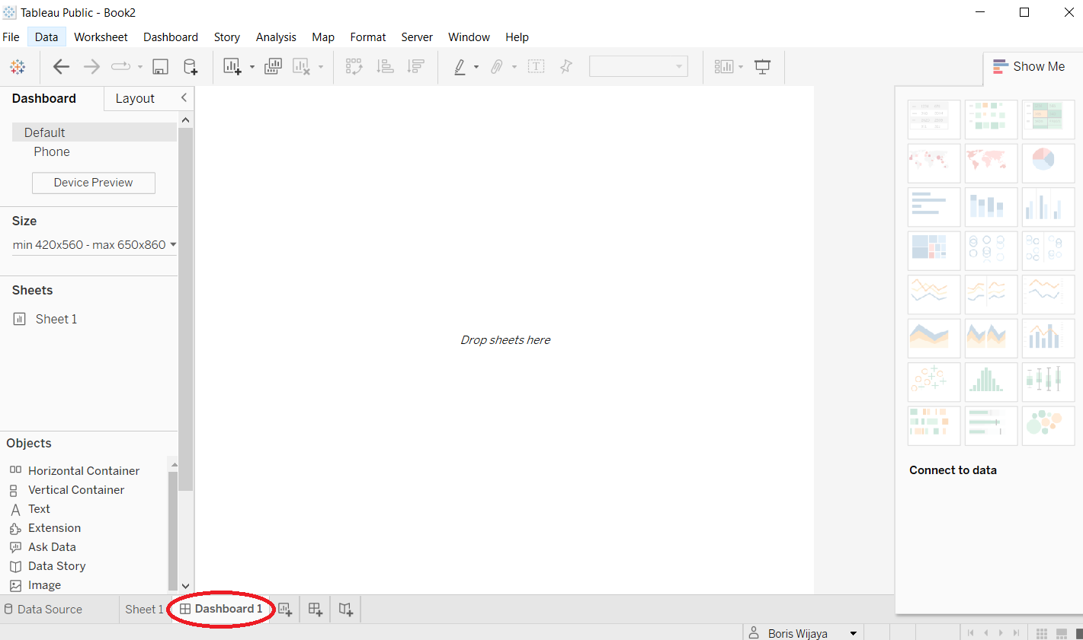

Exercise of Project 3 - Getting data into Tableau

In this project, I learned how to get data into Tableau, first I started the Tableau system.

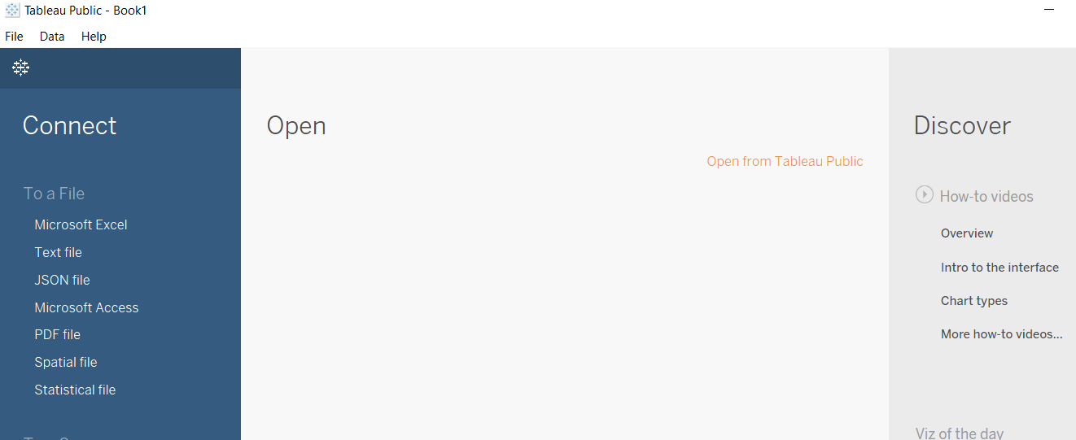

Then I navigated to the “Microsoft Excell” on the left pane to open the my computer window page

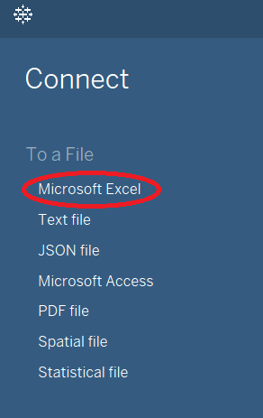

Next, from the window page I select the data set “simple-data-bogoughs.xlsx” that I downloaded before from lab Moodle and open it

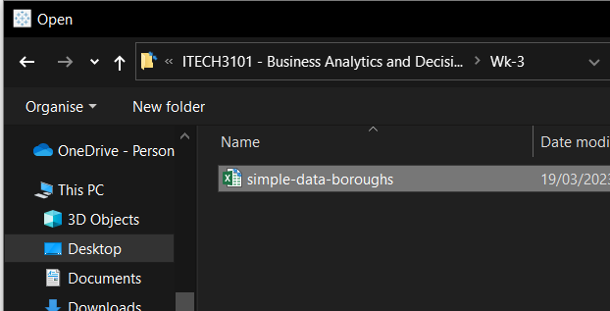

After that, The Tableau will show view of the data set choosen and by clicking “Sheet 1” it will show the worksheet area

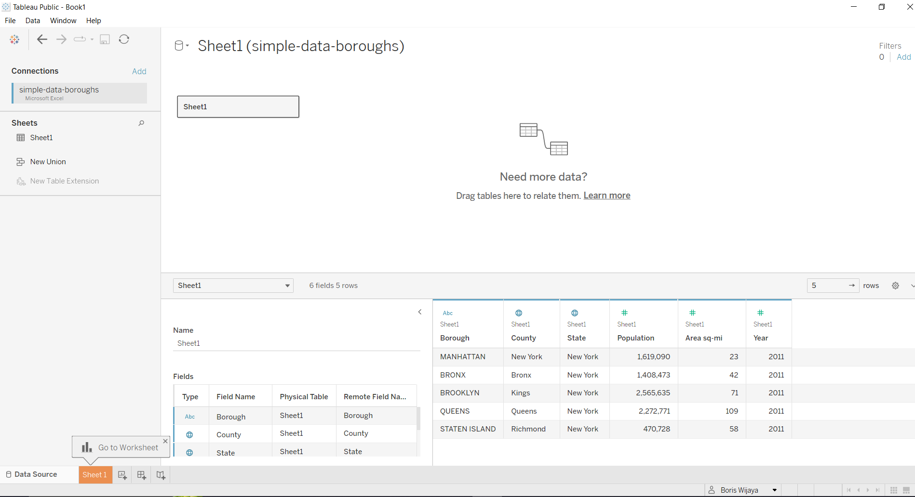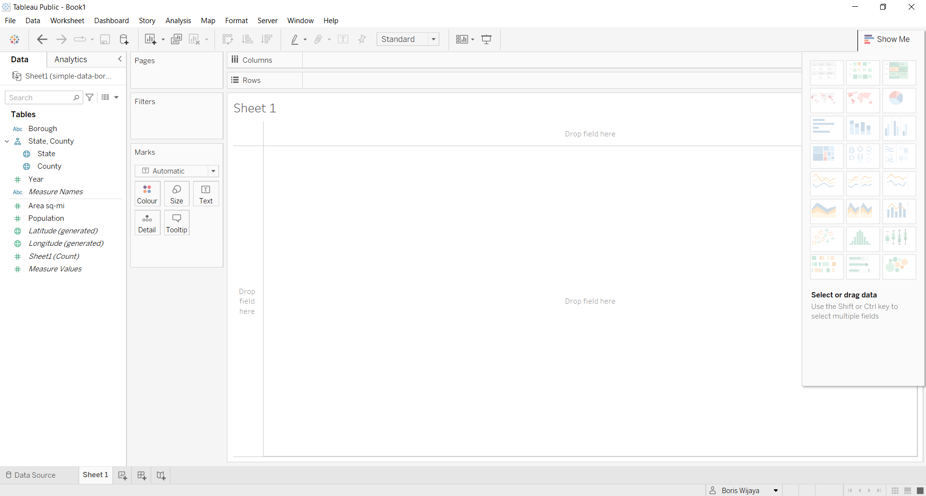

The worksheet view also inlclude all the data types and operations symbols belong to that data set

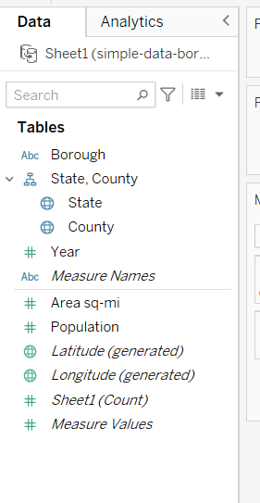

Exercise of Project 4 - Getting data out of Tableau

In this project, I learned how to get data out of Tableau using the data set from before.

First from the worksheet page I navigated to data source at the upper part of the page and point to Sheet 1

Exercise of Project 5 - Getting data out of Tableau 2

Exercise of Project 6 - Simple data visualizations

Answering Questions of Week-3 Lab

1. Discuss the differences between machine learning and deep learning.

Machine learning is the algorithm used by artificial intelligence to perform and learn to do simple tasks without the need for human interventions. In general, the learning process of these algorithms can either be supervised or unsupervised, depending on the data being used to feed the algorithms.

Supervised learning is sub-method of machine learning with the most human intervention to teach computers

how to respond to data input

Deep Learning algorithms are both as a sophisticated and complex compare to machine learning

1. What are the necessary conditions for AI to be able to automate decision making?